Logbook for the Week
Name: Elianne Ngetchou
Team: Team 3

Task #318
Location: Office (E-1017)
Date: 2025/01/14
Time: 8:30 AM – 10:00 AM
Time Billed: 1.5 hour* $75/hr = $112.50
Description:
Reinitialized the server to create two RAID configurations: RAID 1 for the OS and another RAID for virtual machines. During the process, the server failed to power on, so I transferred the RAID controller to another server with a non-functional RAID. After that, I created the two RAID setups, installed Windows Server 2022, and configured the system, including time, date, and IP address. While booting, the server displayed an error requiring an F1 input, indicating a faulty RAM stick. I accessed the BIOS setup via iDRAC settings, checked the event log to identify the defective RAM, then powered down the server and replaced the faulty RAM module
Task #308
Location: Room (E-1019)
Date: 2025/01/21
Time: 1:30 PM – 2:30 PM
Time Billed: $0.5hours * $75/hr = $37.5
Description:
Updated the physical network topology diagram to include missing port numbers and IP addresses. Analyzed the network infrastructure, including connections between switches, routers, and servers in different rooms. Verified VLAN assignments and ensured accurate documentation of the network layout. Also confirmed out-of-band management via the Cyclades console box
Physical Connectivity

Switches
- E1019-APPStd-ExtSW1 (External Switch in Room E1019):
  - Connects to external routers (T3RtrE1019,) via fiber links.
  - Connects to E1019-APPStd-IntSW1 using trunk ports.
  - Provides connections to the DMZ VLAN and external-facing interfaces of the routers.
- E1019-APPStd-IntSW1 (Internal Switch in Room E1019):
  - Connects to Rack7Sw1 via fiber or copper uplinks.
  - Provides internal VLAN access for servers in Rack 7.
  - Connects to internal routers (T3RtrC1002.) for internal traffic.
- Rack7Sw1 (Internal Switch in Room E1017):
  - Directly connects to the servers (R7S6) using copper Ethernet connections.
  - Uplinks to E1019-APPStd-IntSW1.
- C1002-APPStd-IntSW3 (Internal Switch in Room C1002):
  - Connects to the internal routers (T3RtrC1002)

. Routers
- External Router (T3RtrE1019)
  - Connect to E1019-APPStd-ExtSW1 for internet and DMZ traffic.
- Internal Router (T3RtrC1002)
  - Connect to C1002-APPStd-IntSW3 for internal network routing.

Cyclades Box
- The Cyclades console box connects to:
  - All routers for out-of-band management.
  - ESXi servers for console-level access.
  - Switches for configuration and monitoring.

Team member | Task ID |  | Task Description | Date | Start Time | End Time | Work Description | Total Hours | Billable Amount
Elianne Ngetchou | 318 |  | Configuration of server | Jan 28th | 11:00am | 12:30pm | Reinitialized the server to create two RAID configurations: RAID 1 for the OS and another RAID for virtual machines. During the process, the server failed to power on, so I transferred the RAID controller to another server with a non-functional RAID. After that, I created the two RAID setups, installed Windows Server 2022, and configured the system, including time, date, and IP address. While booting, the server displayed an error requiring an F1 input, indicating a faulty RAM stick. I accessed the BIOS setup via iDRAC settings, checked the event log to identify the defective RAM, then powered down the server and replaced the faulty RAM module | 1.5hour | $112.50
Elianne Ngetchou | 308 | Physical Topology Diagram |  | Jan 29 | 1:30 pm | 2:30pm | Updated the physical network topology diagram to include missing port numbers and IP addresses. Analyzed the network infrastructure, including connections between switches, routers, and servers in different rooms. Verified VLAN assignments and ensured accurate documentation of the network layout. Also confirmed out-of-band management via the Cyclades console box. | 0.5hour | $37.50

Total Billable Amount= $150+(150*0.15)=$172.5

Pictures
- Server
  - Detached RAID Controller

-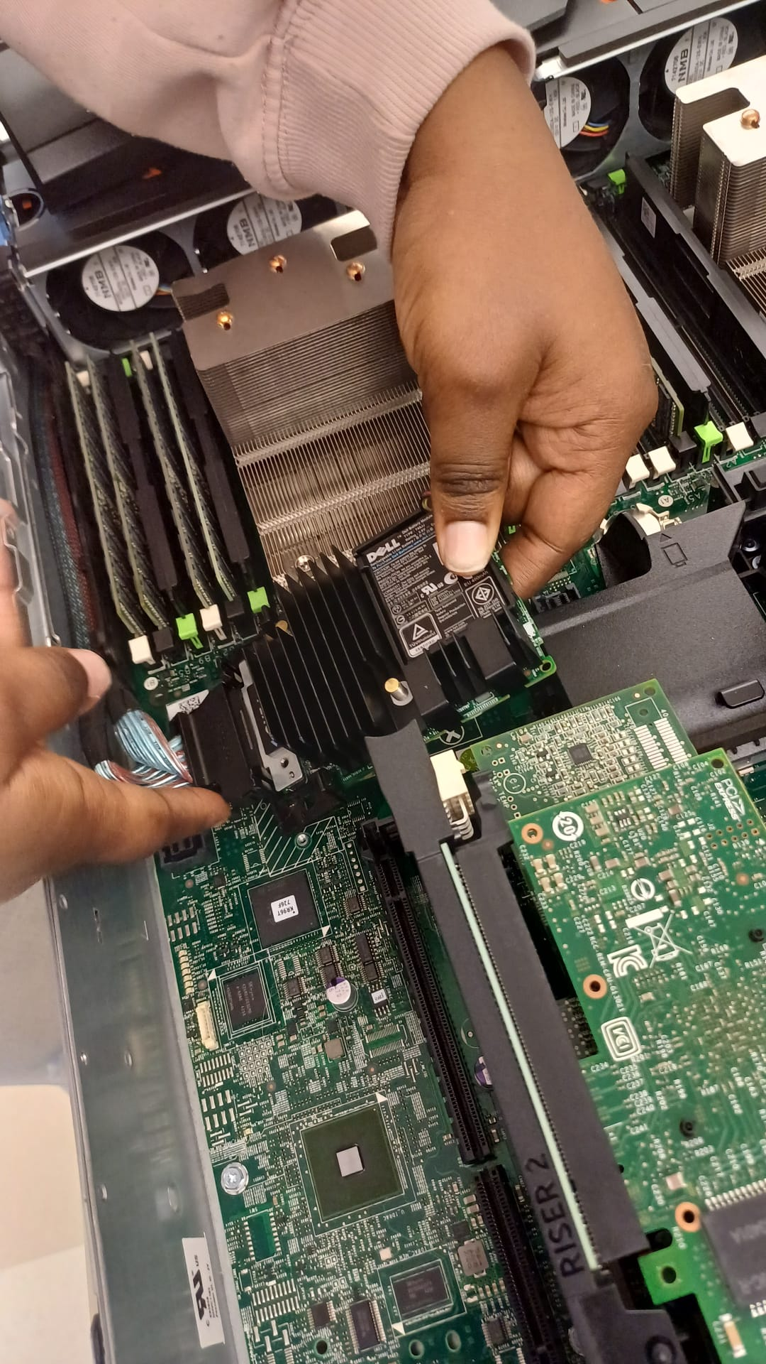
- Replaced PERC
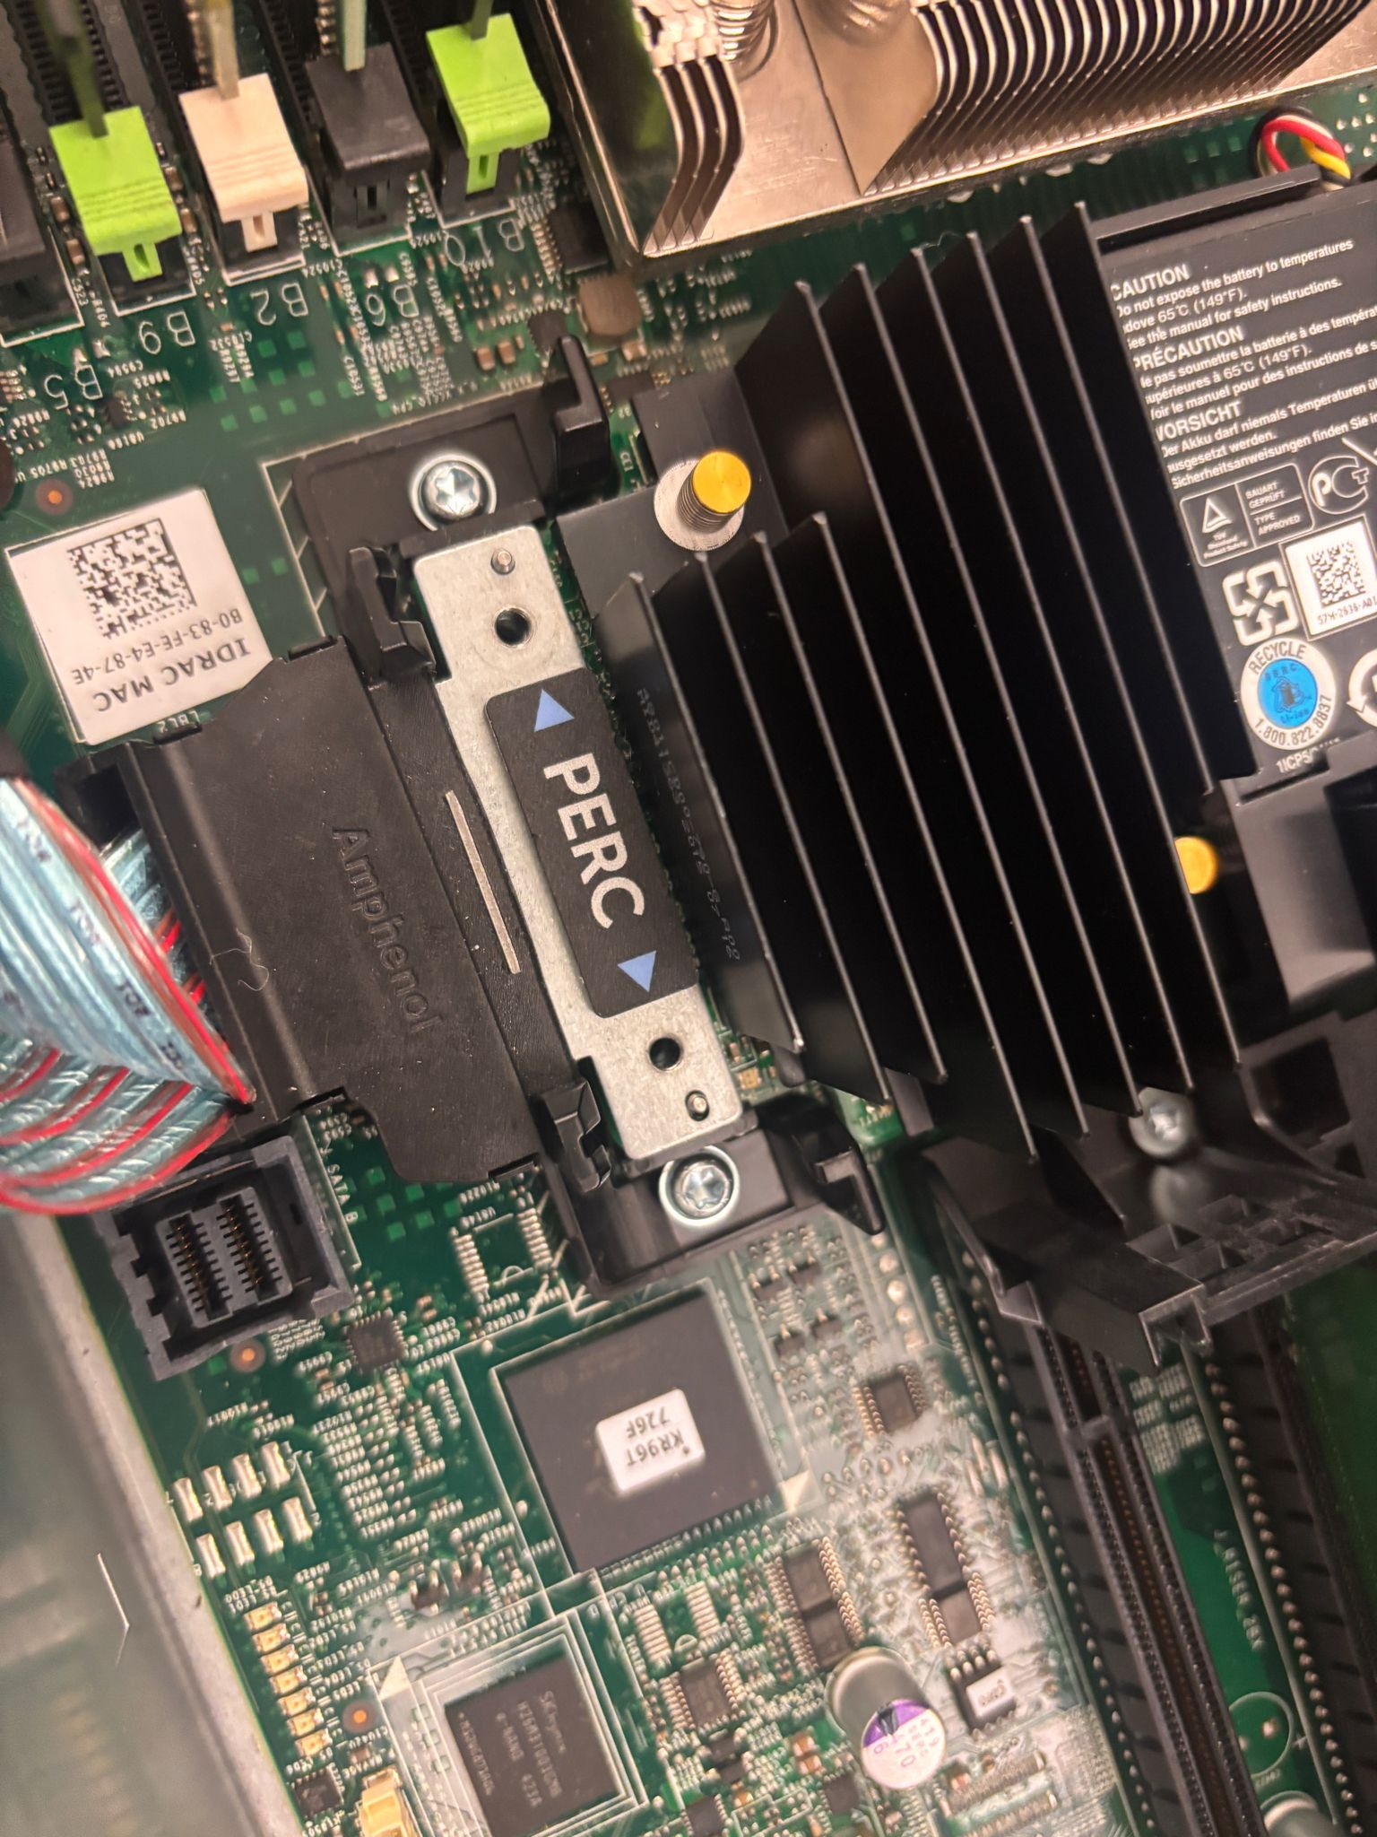
  - Disk in gotten from RAiD 1 and 5
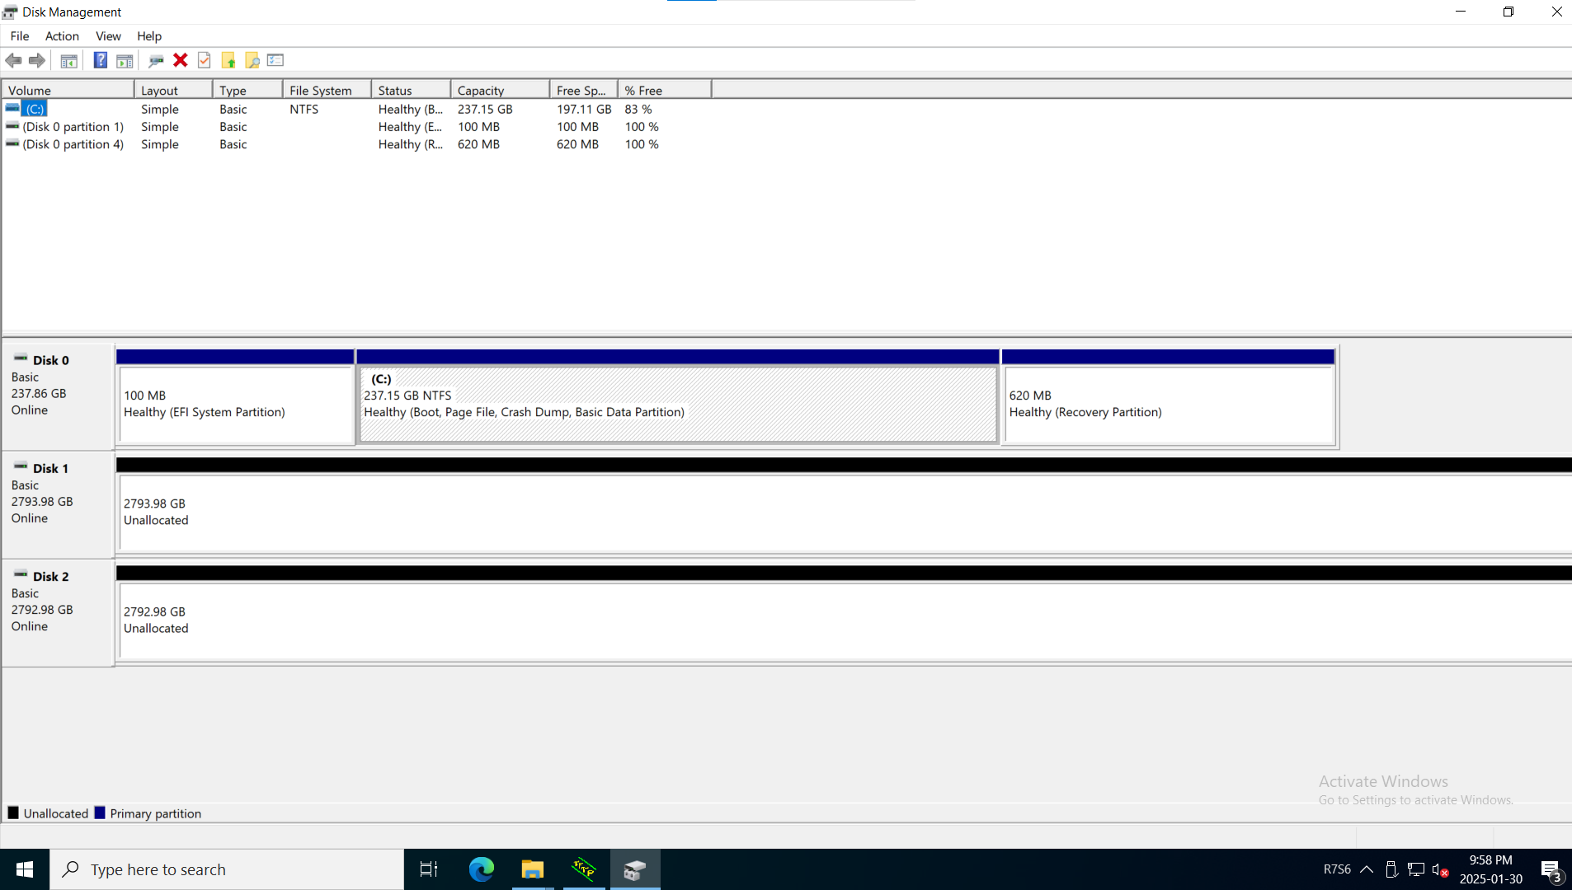
  - Configuring IP Address
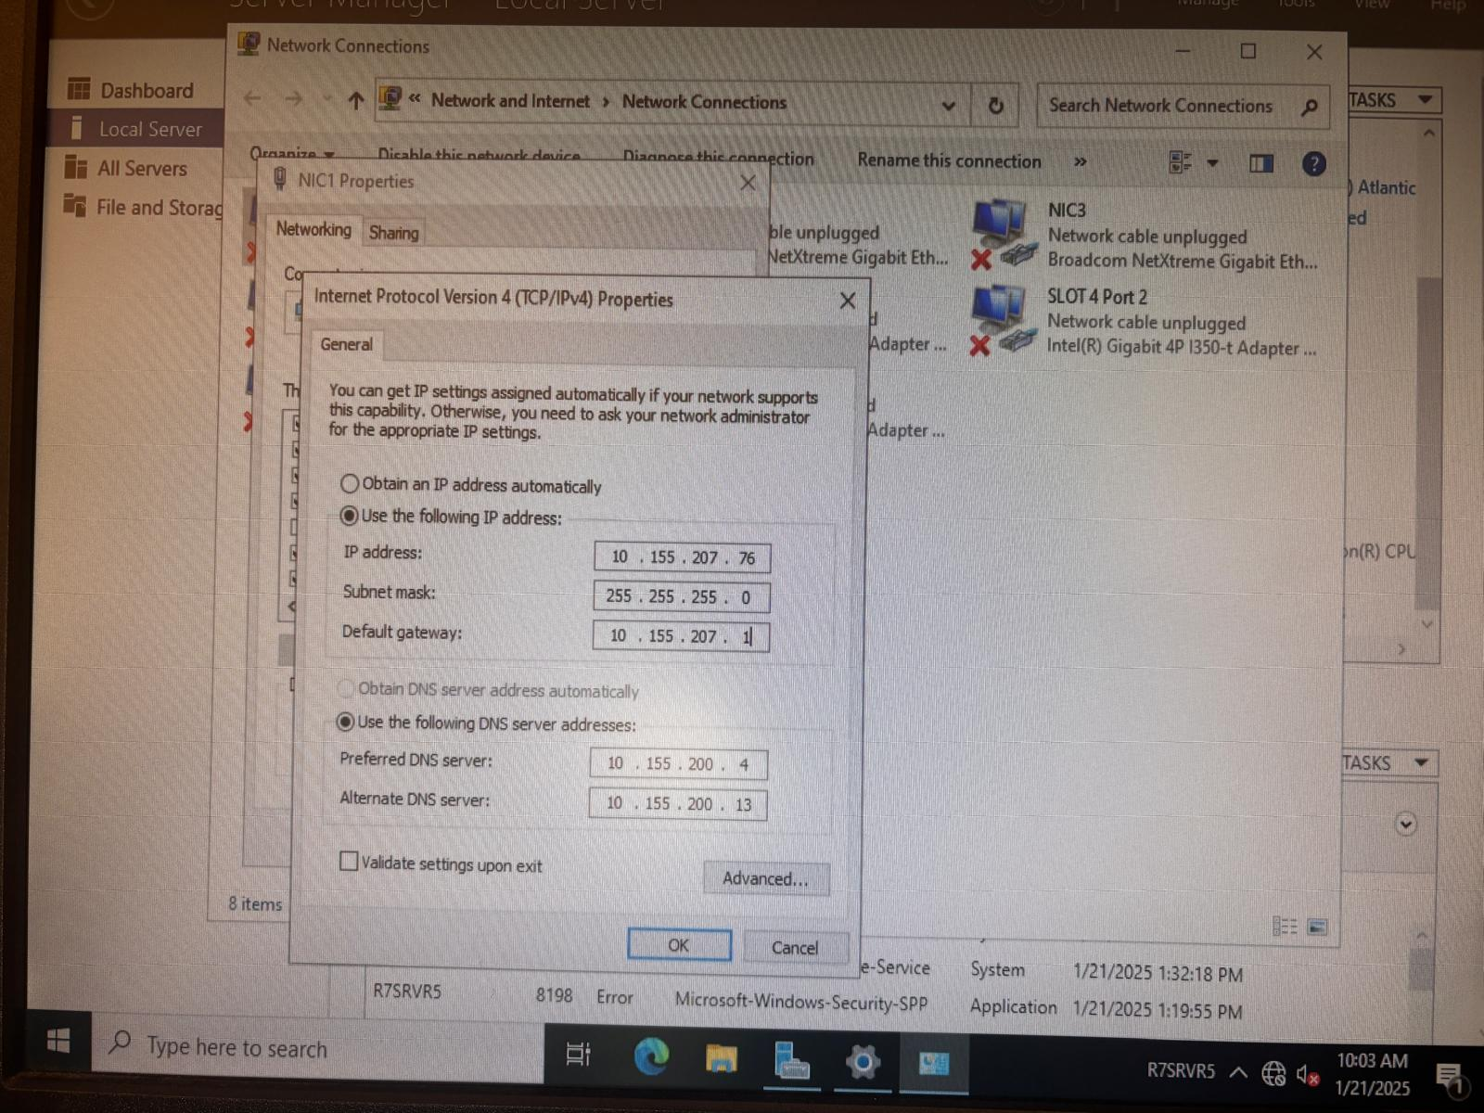

  - Changing username
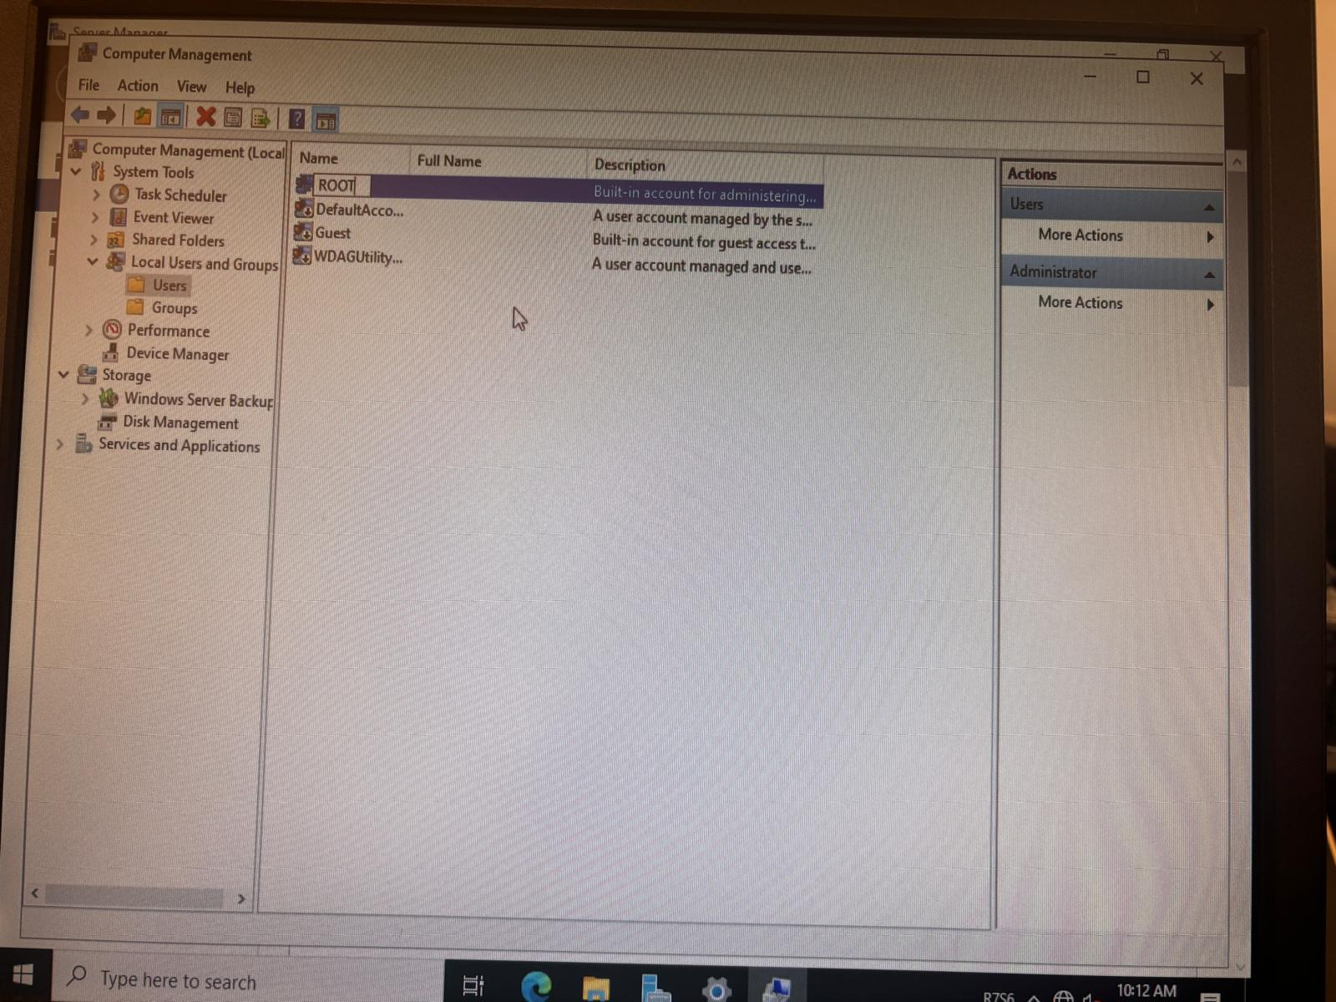

  - Changing date and Time
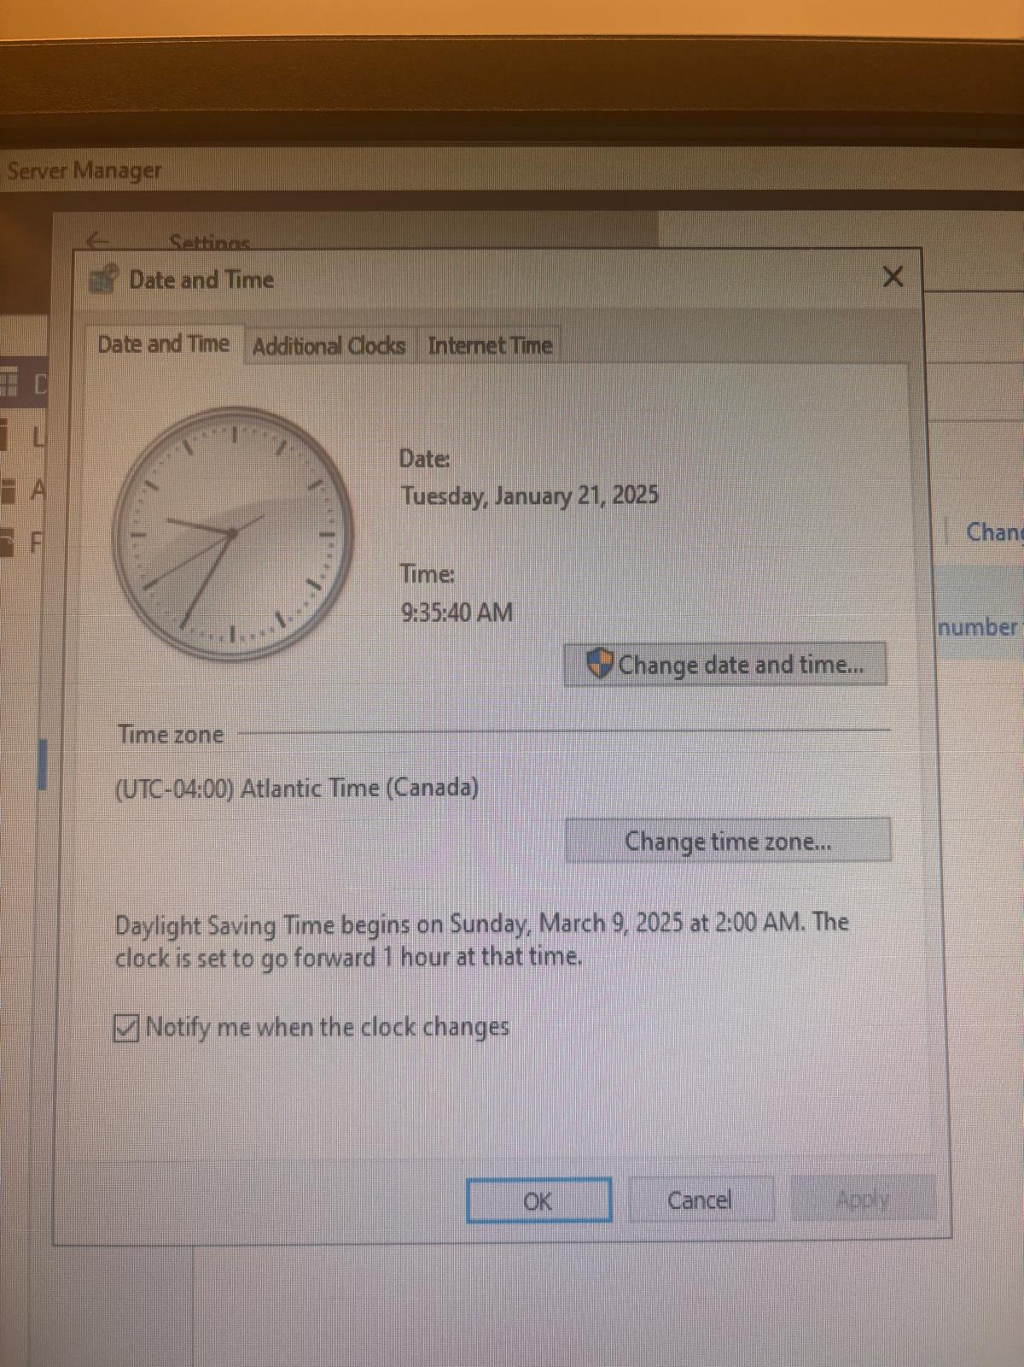

  - Enabling Remote Access
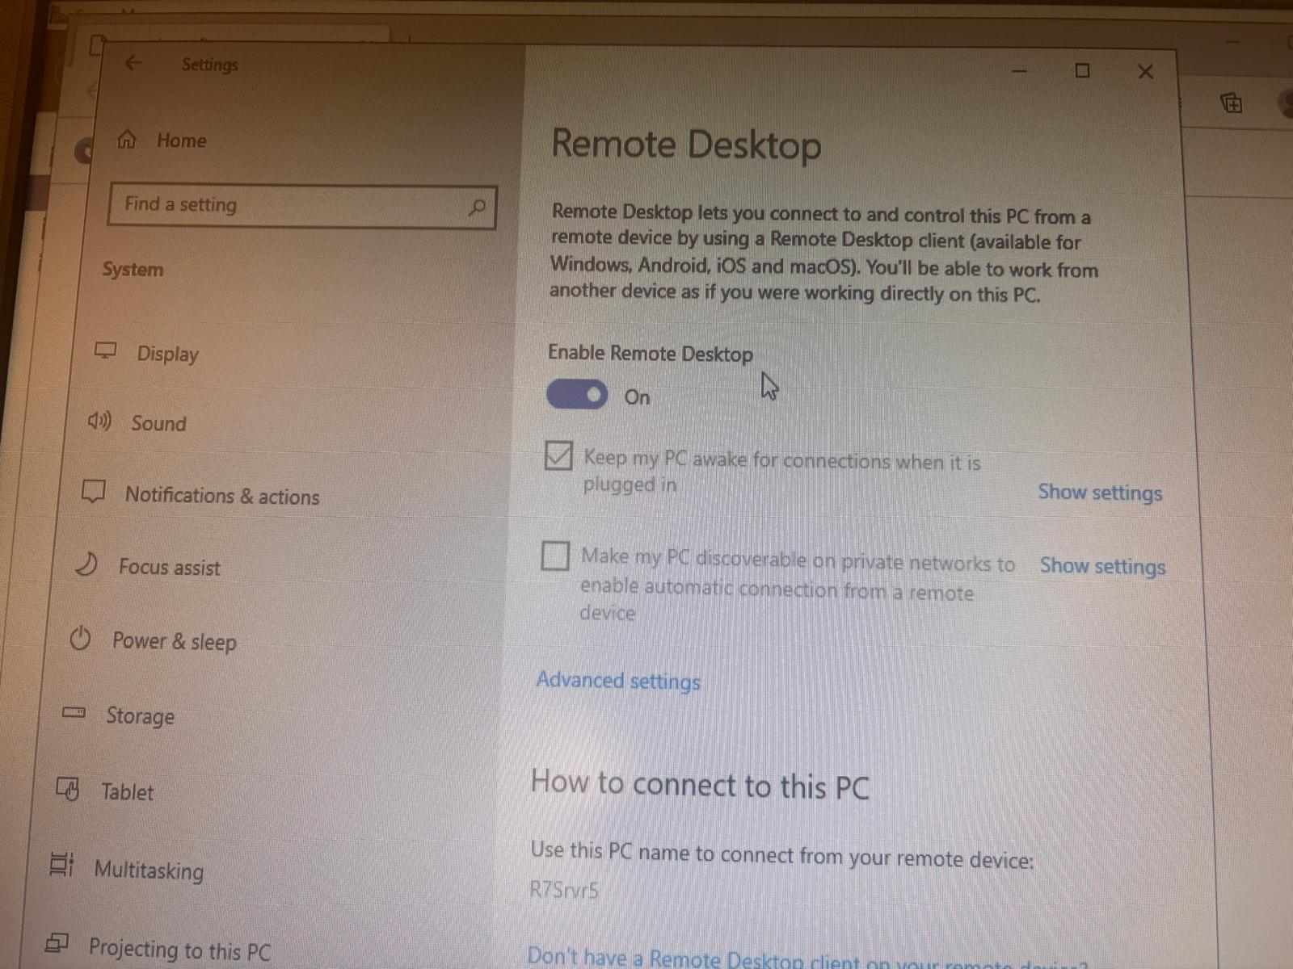

  - Testing if Server Connect to internet
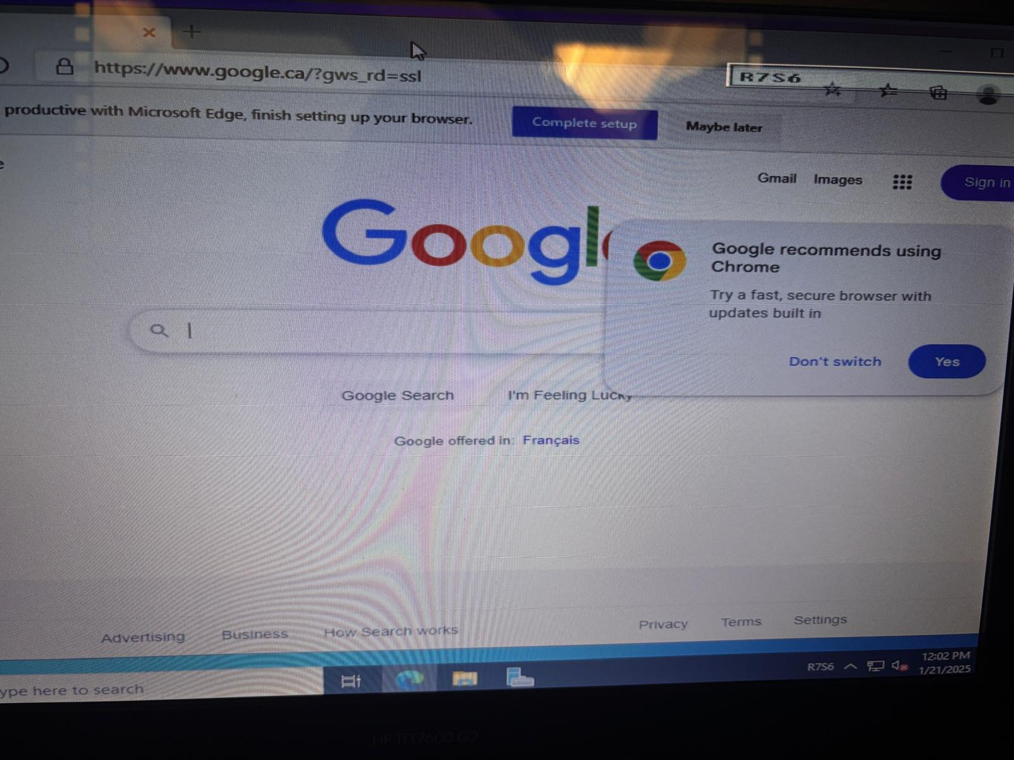

  - Testing Remote access
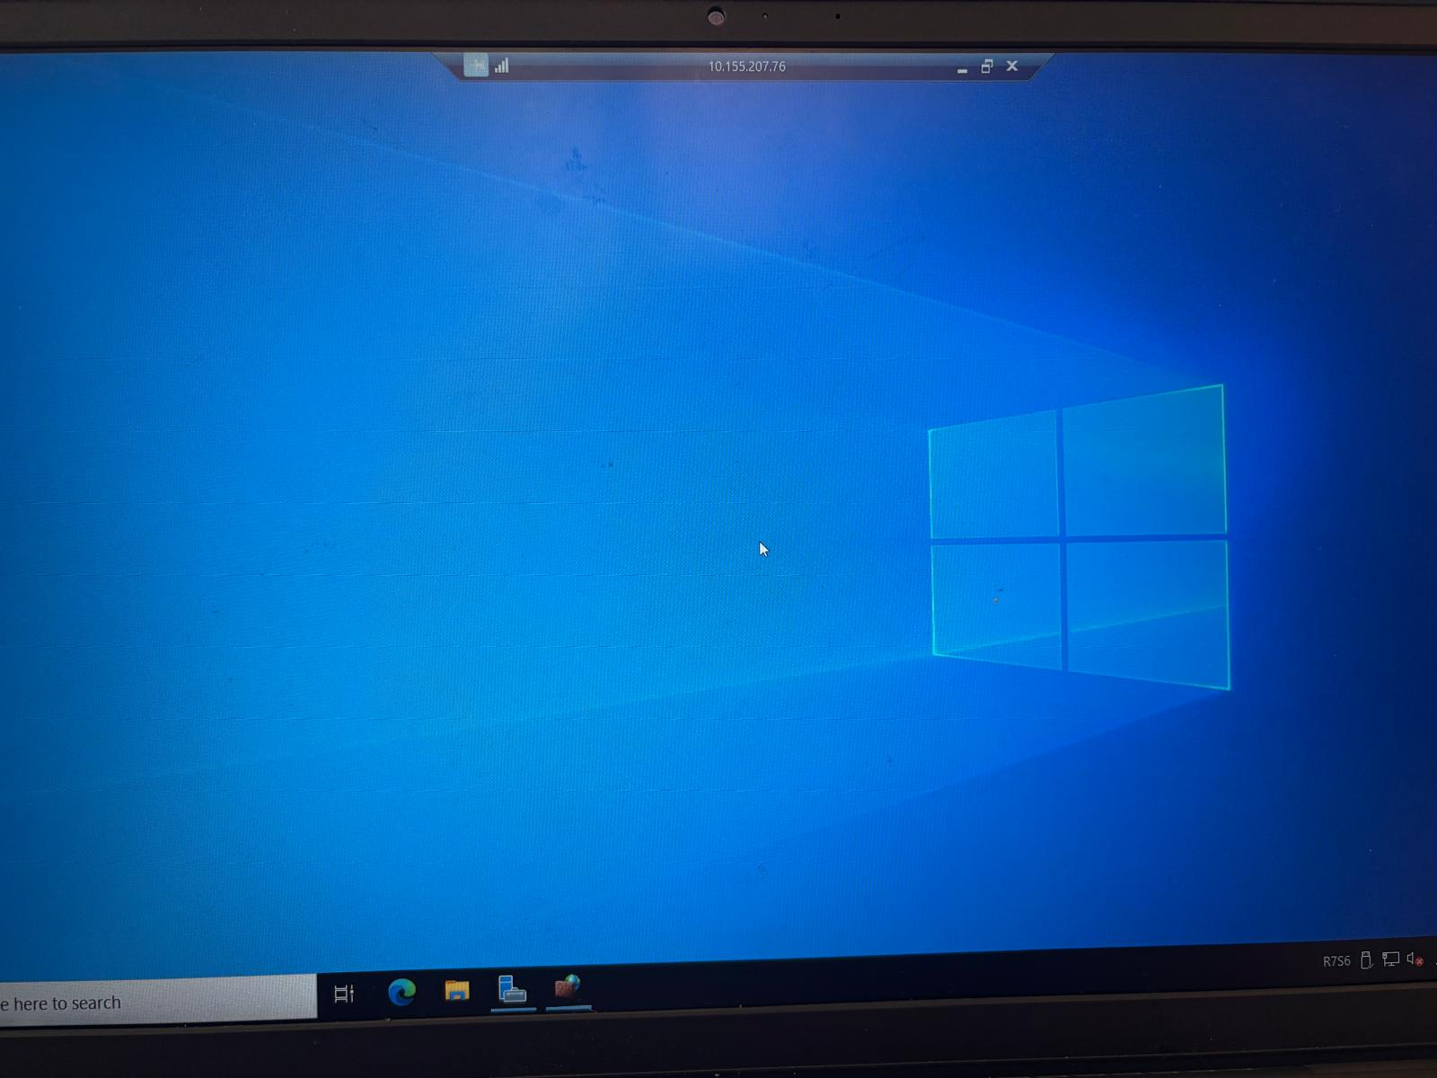

  - TFTP Installed
- 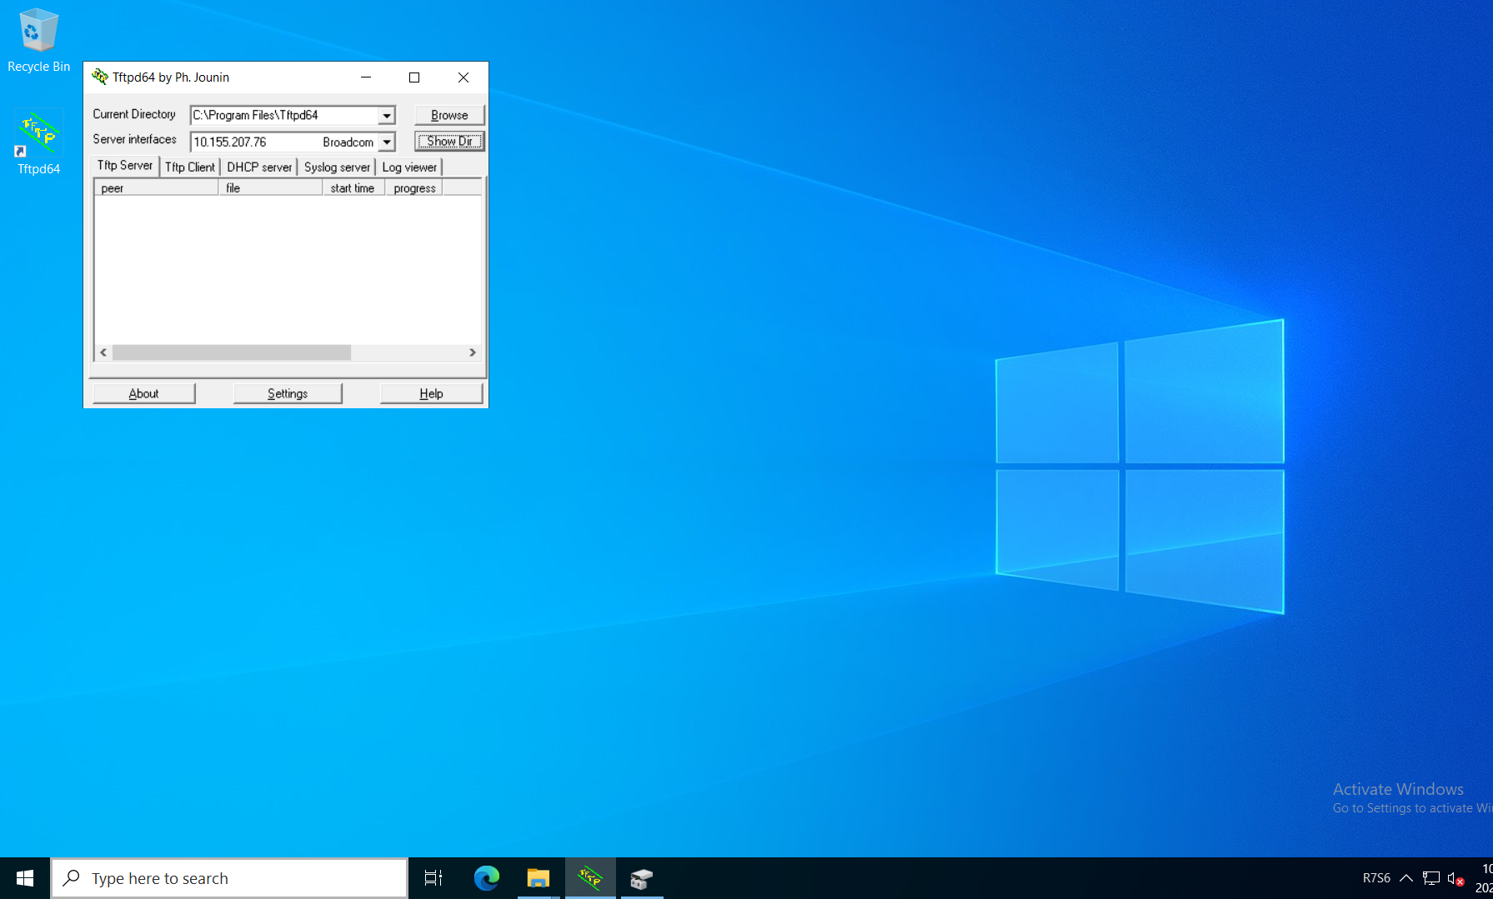Physical Topology

